Notes for exhibitors

- No entry form needed, just turn up with your exhibit between 9.30AM and 11.45AM

- All exhibits must be in place by 12.00PM when the doors will close for judging

- Paper plates will be provided for all exhibits

- All cooked food items must be covered as appropriate

- An entry fee of £1.00 per item or £5.00 for unlimited items is payable on the door

- Judging will take place between 12.00PM and 2.00PM, the judges decisions are final.

- All produce will be offered for sale after the show and a percentage of these sales will be donated to East Anglian Air Ambulance charity. If you do not want your produce sold, please tell the organisers when you come to exhibit your item.

- Any questions please email newfrosthall@outlook.com

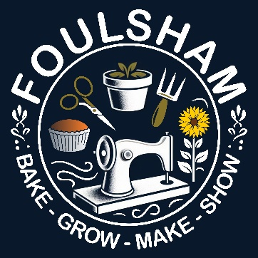

Produce Show at the New Frost Hall
Saturday 12th September 2026

This is a fun event and anyone can enter as many categories as they like, and there is a special section just for children.

The categories (full details overleaf) are:

Fruit & Vegetables | Display of Produce
Flowers | Food
Upcycling | Arts & Crafts
Home Brew | Photography
Category for Children aged 11 and under

Don’t miss this opportunity to show off your talents or just come along to see what others in the village have produced.

The Show opens to all at 2.00 pm with tea and cakes for sale

Prizes will be awarded at 3.00 pm

Fruit and Vegetables
1 | 3 eating apples | 9 | 3 french beans
2 | 3 cooking apples | 10 | 3 onions
3 | 3 pears | 11 | 1 cucumber
4 | 6 berries | 12 | 3 carrots
5 | 6 chillies | 13 | 3 potatoes
6 | 3 peppers | 14 | 1 courgette, marrow or squash
7 | 3 tomatoes | 15 | The craziest shaped vegetable
8 | 3 runner beans | 16 | any other home grown produce

Display of Produce
17 | Display of produce in a container

Flowers |  | Home Brew
18 | A single rose | 24 | A bottle wine
19 | Posy of flowers | 25 | A bottle of beer, lager or ale
20 | 3 blooms of the same flower | 26 | A bottle of steeped alcohol
21 | Arrangement of flowers | 27 | A bottle of non-alcoholic drink
22 | Single house plant
23 | 3 dahlias

Food
28 | Sponge cake | 34 | Jar of marmalade
29 | Fruit cake | 35 | Jar of chutney
30 | Gluten free cake | 36 | Jar of pickle
31 | Savoury bakes | 37 | 6 eggs
32 | Sweet bakes | 38 | 6 sweets
33 | Jar of jam or jelly

Arts & Crafts |  | Photography
39 | Any knitted/crocheted item | 46 | Animals
40 | Any hand stitched item | 47 | Nature
41 | Any machine stitched item | 48 | Architecture
42 | Any textile item | 49 | Anything Else
43 | Art - painting | Upcycling
44 | Art - drawing | 50 | An upcycled item
45 | Craft – any medium

Categories for children under 11 years of age
51 |  | Miniature garden, maximum 60cm x 95cm
52 |  | Vegetable or fruit made into an animal or human form
53 | Any craft item |  | 54 | A Lego creation
55 | 6 fairy cakes or muffins |  | 56 | A jar of flowers

